1. Creating and Renaming Files/Directories

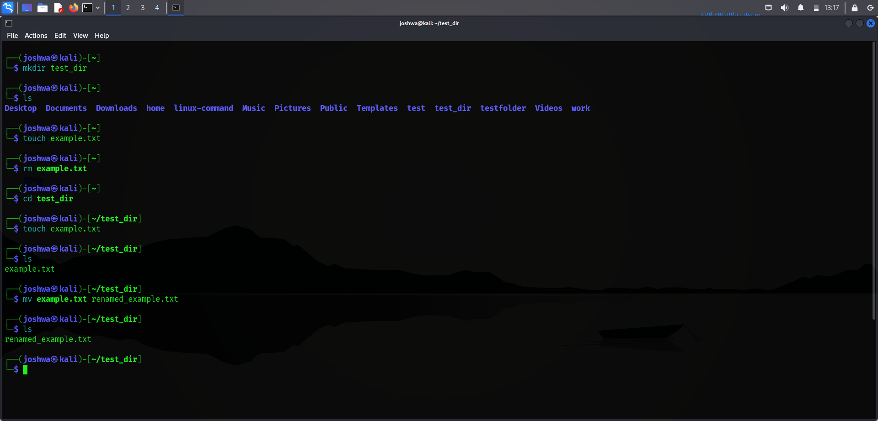

mkdir test_dir → Creates a new folder named test_dir
cd test_dir → Enters inside the folder
touch example.txt → Creates an empty file
mv example.txt renamed_example.txt → Renames the file

2. Viewing File Contents
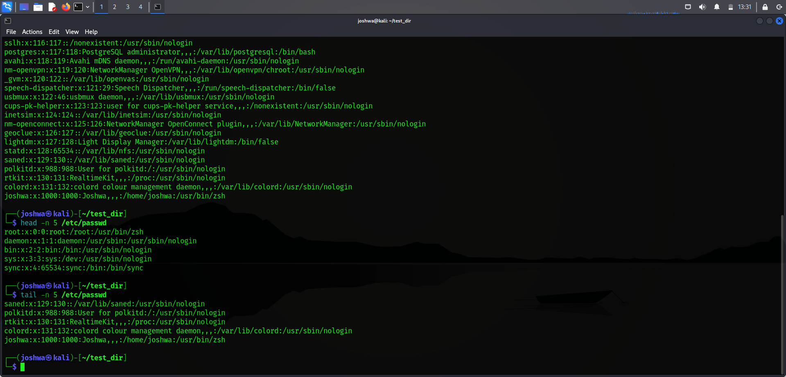
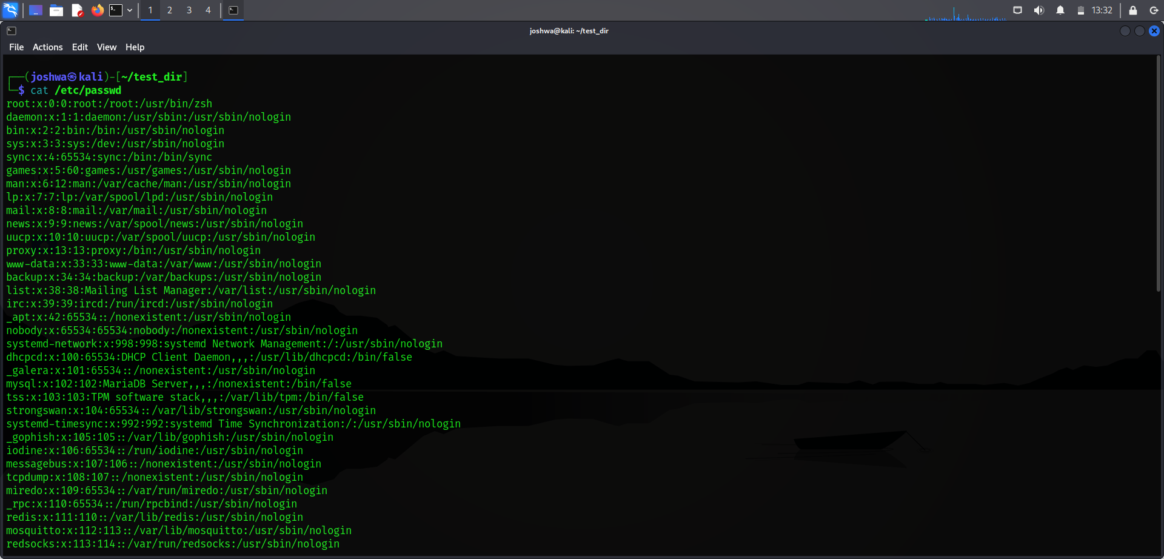

- cat → Displays full file content
- head -5 → Shows first 5 lines
- tail -5 → Shows last 5 lines

3.Searching for Patterns
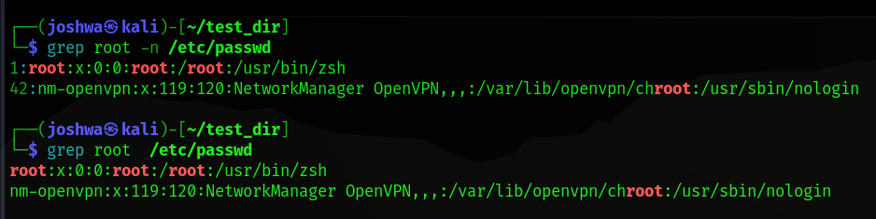

4. Zipping and Unzipping
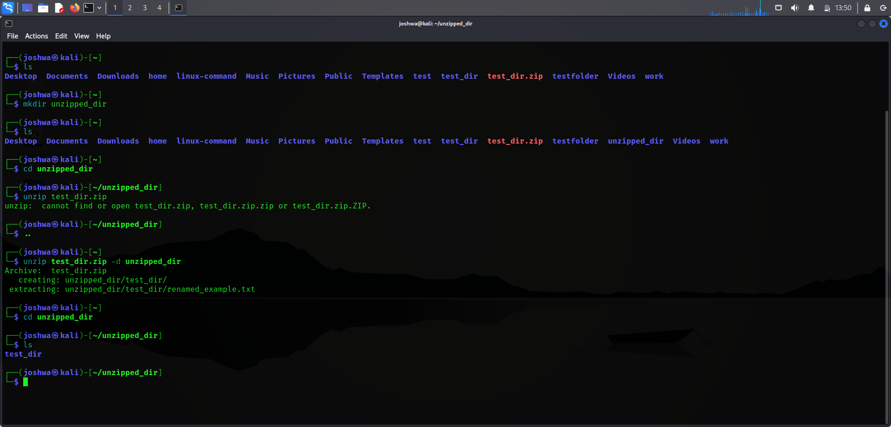

zip -r → Compress folder into zip
mkdir → Create new folder
unzip → Extract zip into folder
5. Downloading Files

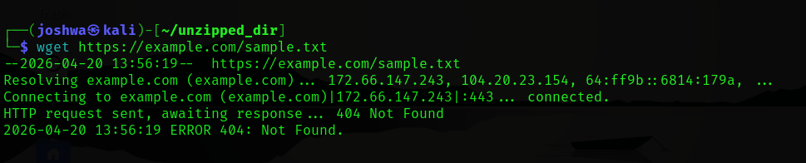
wget downloads file from internet using URL

6. Changing Permissions
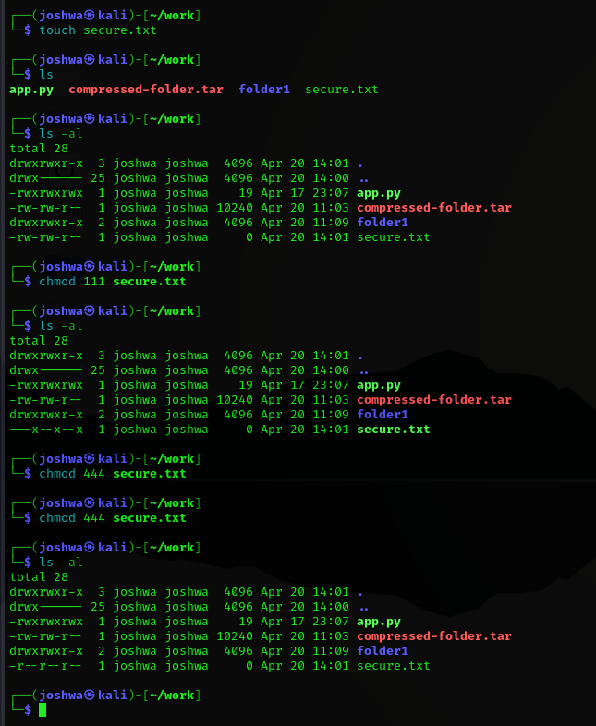

touch → creates file
chmod 444 → read-only for everyone (no write, no execute)
7. Environment Variable

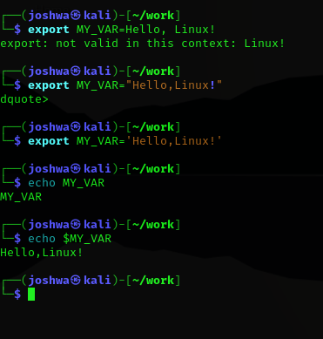

export → creates environment variable
echo $MY_VAR → displays value

